IBM® Software

Maximo Manage Autodesk Viewer Plug-in Install Guide

Document version 8.x

IBM contact: [tknowles@us.ibm](mailto:tknowles@us.ibm).com



The Maximo Manage Autodesk Viewer Plugin is released as trial software and distributed on the IBM Developer Community and Github. An existing MAS Manage 8.x license and installation is required. Trial software is not supported by the IBM Maximo support program; however, support is available directly from the IBM Maximo development team for as long as the software is available for download on the IBM Developer Community website. Check the community for the most recent version as well as continued availability. Only an English version is distributed during the trial. Your feedback is important because the software is being evaluated for possible integration with other Maximo products. Send all support questions and feedback to tknowles@us.ibm.com

**© Copyright International Business Machines Corporation 2011.**

US Government Users Restricted Rights – Use, duplication or disclosure restricted by GSA ADP Schedule Contract with IBM Corp.

Contents

1 Installation Instructions 4

1.1 Supported Version 4

1.2 Deploy Viewer Plugin 4

1.3 Import Autodesk Certificates 5

1.4 Configure BIM directories using PVC 6

1.5 Monitoring Build 6

1.6 Configure System Properties 78

# Installation Instructions

## Supported Version

This version of the Autodesk Viewer Plug-in is only intended for install on Maximo Manage 8.x or higher.

*The Autodesk Viewer uses REST and the Maximo integration Framework. To function it must be able to authenticate to the Maximo REST API using the UI session context.*

|  |  |
| --- | --- |
| Tip | If your Maximo environment is virtualized, create a snapshot before starting the install. |

## Deploy the Maximo Autodesk Viewer Plugin, customization.zip and configure BIM directories using PVC

1. Log in to Maximo Application Suite as a system administrator.
2. From the catalog, on the **Applications** tab, select the Manage tile.
3. On the application details page, click **Actions** and select **Update configuration**.

1. In the **Customization** row on the Update Manage configuration window, click the **Edit** icon.
2. In the Customization section of the configuration window, specify the URL for the BIM archive file.
   * Note – The BIM archive is a .zip included in zip download from the community site. *(Example – Manage-BIMFV-10242023.zip)*
3. In the Persistent Volume claims section of the configuration window, specify the following persistent volumes that will be used to store BIM files.

|  |  |  |
| --- | --- | --- |
| Mount Path | PVC Name | Size |
| **/bim/Models** | bim-models | 100MI |
| **/bim/docs** | bim-docs | 100MI |
| **/bim/import** | bim-import | 100MI |

1. After you have completed the configuration of manage click the **Apply Changes** button. The activation in the MAS workspace could take a few hours before the build is completed.

## Import Autodesk SSL Certificate

If the Autodesk Viewer is used, the MAS server must make an SSL connection to the Autodesk cloud services. The service uses a VeriSign signed certificate. By default, the VeriSign root certificate is not in the WebSphere trust store, so the Autodesk certificate is not trusted and the connections fails. The certificate can be imported in the MAS Manage System console.

1. Go to Forge API in Firefox browser.
2. <https://developer.api.autodesk.com>
3. 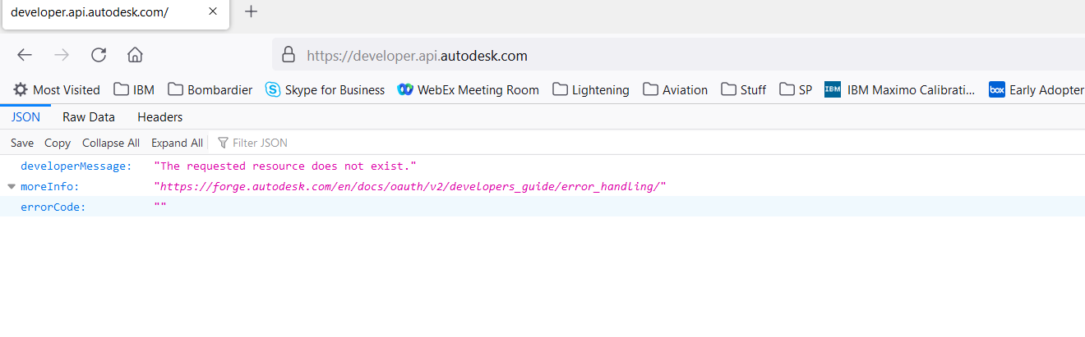
4. 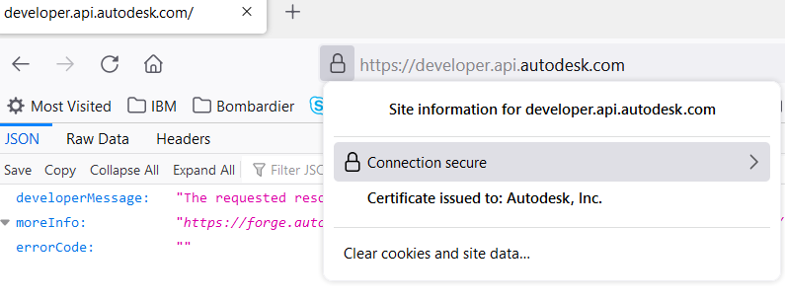
5. 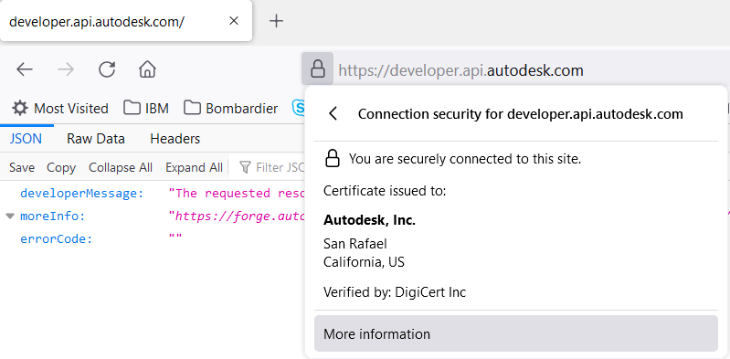
6. 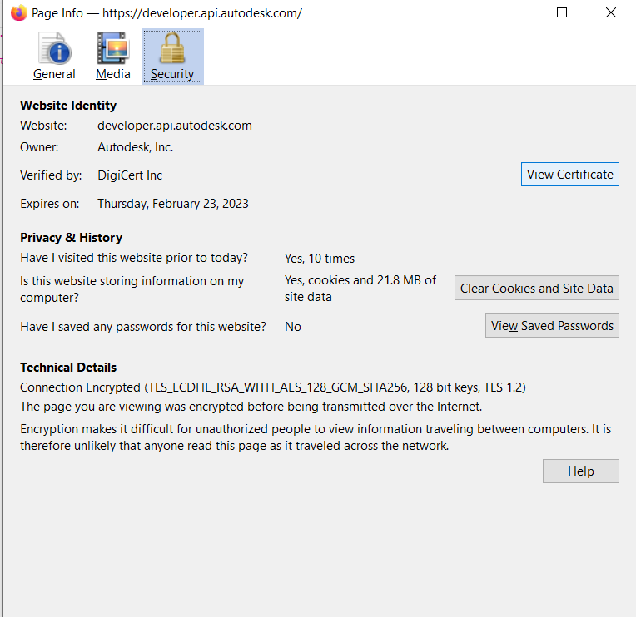
7. 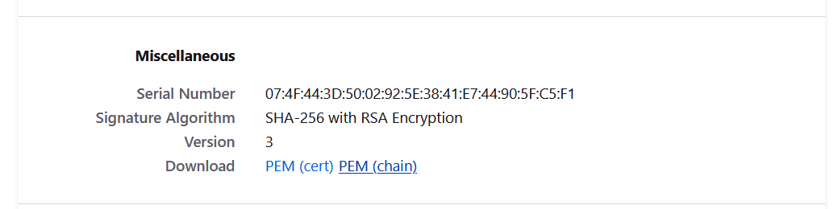
8. 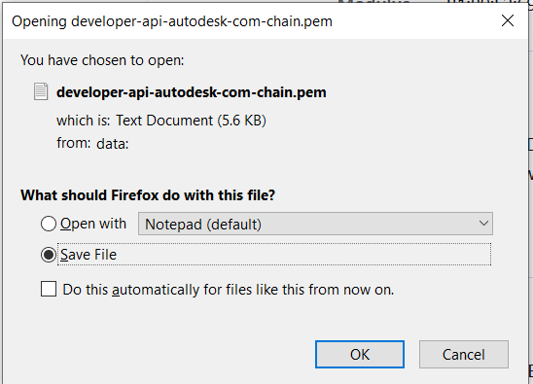
9. Open with Notepad
10. Copy 1st certificate section from -----BEGIN CERTIFICATE to END CERTIFICATE--------
11. Log into MAS and Open Suite Administration
12. Click on Catalog
13. Click on Manage
14. Under Setting, select Imported Certificates.
15. Click on Edit Setting option.
16. At the bottom select Add another + option
17. Enter an alias such as ‘AUTODESK’ and paste the copy from step 1 into this Certificate content section.
18. Repeat this step until all certificate sections have been added.
19. 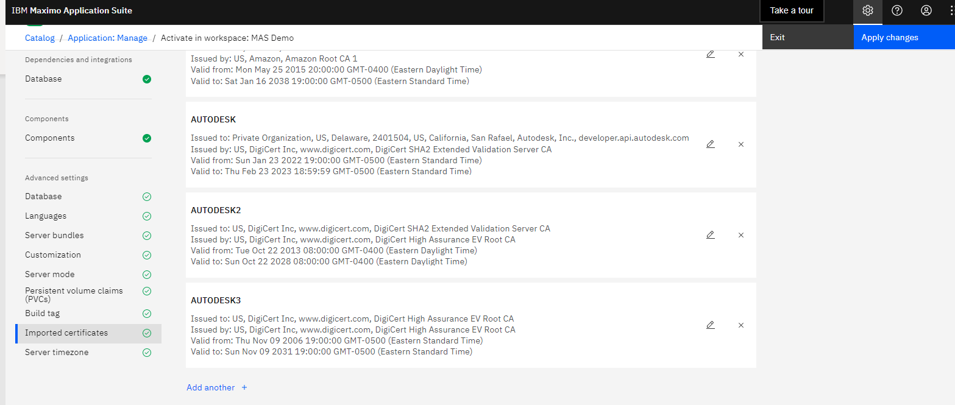
20. Then select Apply Changes.
21. Alternative is to follow the steps listed here to import the certificate to MAS: https://www.ibm.com/docs/en/maximo-manage/continuous-delivery?topic=administering-trusted-certificates

## Configure System Properties

To configure system properties:

* Goto->System Configuration->Platform Configuration->System Properties
* Click the twisty to display the filter.
* Enter bim in the property name filter field and press enter.
* When you have updated properties as described below, check the box to the left of the properties you have edited to select them and select live refresh from the toolbar.

### APS Key and Secret

The Autodesk Viewer is a cloud based WebGL application to use it you must have an account with Autodesk and credentials for the Autodesk Platform Service. The version of the viewer provided for 3rd party integration is different from that used by BIM360 accounts and requires separate credentials. You may sign up for a trail here:

<https://aps.autodesk.com/>

Once you acquire your Key and Secret from Autodesk they must be installed into Maximo. To do so, set the following System Properties:

'bim.viewer.LMV.key'

'bim.viewer.LMV.secret'

### Working Directory

You may override the default values specified for the working directories in the Maximo system properties. They are:

* bim.import.dir => /bim/import
* bim.model.dir => /bim/models
* bim.import.docdir => /bim/docs

Insure that these directories exist

### Selecting the Active Viewer

Multiple viewer plug-ins may be installed in a single Maximo instance. However, only one viewer may be active at a time. The active viewer is selected vie the system property:

bim.viewer.active

Valid values are:

***lmv*** – To select the Forge Viewer

***vendor*** – To deactivate all viewers

Additional values may be defined by 3rd party viewers

The Forge viewer install sets the value to “***lmv***”

 ®

© Copyright IBM Corporation 2022

IBM United States of America

Produced in the United States of America

US Government Users Restricted Rights - Use, duplication or disclosure restricted by GSA ADP Schedule Contract with IBM Corp.

IBM may not offer the products, services, or features discussed in this document in other countries. Consult your local IBM representative for information on the products and services currently available in your area. Any reference to an IBM product, program, or service is not intended to state or imply that only that IBM product, program, or service may be used. Any functionally equivalent product, program, or service that does not infringe any IBM intellectual property right may be used instead. However, it is the user's responsibility to evaluate and verify the operation of any non-IBM product, program, or service.

IBM may have patents or pending patent applications covering subject matter described in this document. The furnishing of this document does not grant you any license to these patents. You can send license inquiries, in writing, to:

IBM Director of Licensing  
IBM Corporation  
North Castle Drive  
Armonk, NY 10504-1785   
U.S.A.

**The following paragraph does not apply to the United Kingdom or any other country where such provisions are inconsistent with local law:**

INTERNATIONAL BUSINESS MACHINES CORPORATION PROVIDES THIS PAPER “AS IS” WITHOUT WARRANTY OF ANY KIND, EITHER EXPRESS OR IMPLIED, INCLUDING, BUT NOT LIMITED TO, THE IMPLIED WARRANTIES OF NON-INFRINGEMENT, MERCHANTABILITY OR FITNESS FOR A PARTICULAR PURPOSE. Some states do not allow disclaimer of express or implied warranties in certain transactions, therefore, this statement may not apply to you.

This information could include technical inaccuracies or typographical errors. Changes may be made periodically to the information herein; these changes may be incorporated in subsequent versions of the paper. IBM may make improvements and/or changes in the product(s) and/or the program(s) described in this paper at any time without notice.

Any references in this document to non-IBM Web sites are provided for convenience only and do not in any manner serve as an endorsement of those Web sites. The materials at those Web sites are not part of the materials for this IBM product and use of those Web sites is at your own risk.

IBM may have patents or pending patent applications covering subject matter described in this document. The furnishing of this document does not give you any license to these patents. You can send license inquiries, in writing, to:

IBM Director of Licensing

IBM Corporation

4205 South Miami Boulevard

Research Triangle Park, NC 27709 U.S.A.

All statements regarding IBM's future direction or intent are subject to change or withdrawal without notice, and represent goals and objectives only.

This information is for planning purposes only. The information herein is subject to change before the products described become available.

If you are viewing this information softcopy, the photographs and color illustrations may not appear.

**Trademarks**

IBM, the IBM logo, and ibm.com are trademarks or registered trademarks of International Business Machines Corporation in the United States, other countries, or both. If these and other IBM trademarked terms are marked on their first occurrence in this information with a trademark symbol (® or ™), these symbols indicate U.S. registered or common law trademarks owned by IBM at the time this information was published. Such trademarks may also be registered or common law trademarks in other countries. A current list of IBM trademarks is available on the web at "Copyright and trademark information" at <http://www.ibm.com/legal/copytrade.shtml>.

Autodesk, the Autodesk logo, BIM360, NavisWorks, Revit, are registered trademarks or trademarks of Autodesk, Inc., and/or its subsidiaries and/or affiliates in the USA and/or other countries. All other brand names, product names, or trademarks belong to their respective holders. Autodesk reserves the right to alter product and services offerings, and specifications and pricing at any time without notice, and is not responsible for typographical or graphical errors that may appear in this document. © [2016] Autodesk, Inc. All rights reserved.

Microsoft, Windows, Windows NT, and the Windows logo are trademarks of Microsoft Corporation in the United States, other countries, or both.

Other company, product, or service names may be trademarks or service marks of others.

**Notices**

Apache POI

Copyright 2009 The Apache Software Foundation

This product includes software developed by The Apache Software Foundation (<http://www.apache.org/>).

This product contains the DOM4J library (<http://www.dom4j.org>). Copyright 2001-2005 (C) MetaStuff, Ltd. All Rights Reserved.

This product contains parts that were originally based on software from BEA. Copyright (c) 2000-2003, BEA Systems, <http://www.bea.com/>.

This product contains W3C XML Schema documents. Copyright 2001-2003 (c) World Wide Web Consortium (Massachusetts Institute of Technology, European

Research Consortium for Informatics and Mathematics, Keio University)

This product contains the Piccolo XML Parser for Java (http://piccolo.sourceforge.net/). Copyright 2002 Yuval Oren.